

UHPS
Test System
Collaboration Initiative

  - B1. Submission Form Document​
​
​
​
​
​
​
​
​
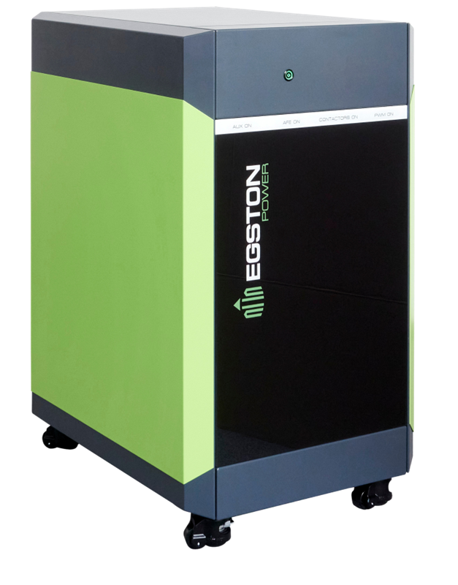
​
​
​
​
​
​
​
​
​
​

Table of Contents
I. Introduction 3
II. Submission Form 3
II.1. Institution Information 3
II.2. Team Information 4
II.3. Research Proposal(s) 5
II.4. Research Timeline 7
II.5. Additional Information 7

​
​
​
​
​
​
​

Introduction
EGSTON Power Electronics is committed to driving innovation and supporting groundbreaking research in power electronics and related fields. Through this initiative, we aim to enable universities worldwide to develop new ideas and research projects using our cutting-edge with our newly released UHPS Test System. By providing access to advanced equipment, we seek to foster collaboration between academia and industry, promoting advancements in renewable energy, electric vehicles, power grids, and more.
We invite technical universities with a strong interest in power electronics to submit proposals for the use of the UHPS Test System. Selected institutions will have the opportunity to use the equipment for the requested amount of time free of charge.

Submission Form
Please fill out the tables below according to your research plan. Please note that the awarding decision will be based on the answers given below according to the A1. UHPS Test System Collaboration Initiative Call criteria and evaluation process.

II.1. Institution Information
Official Address
Name of Institution
Department/Faculty
Address Line 1
Address Line 2
Country
ZIP

Shipping Address
Name of Institution
Department/Faculty
Address Line 1
Address Line 2
Country
ZIP

II.2. Team Information
Primary Contact Person
Name
Title
Email
Phone Number
Team members (please add further members in the same manner)
Name
Role
Relevant Expertise/Experience
Name
Role
Relevant Expertise/Experience
Name
Role
Relevant Expertise/Experience

II.3. Research Proposal(s)
Main Research Project
Proposed Research Title 1.
Objective
Provide a summary of the goal of your research and its significance in advancing knowledge in power electronics or related fields.
Research Description
Describe how you intend to use the UHPS Test System for your research. Include the following:
- E.g.: Block diagram, including voltage-current-power levels, interfaces, bandwidth requirements.
- Key methodologies and experimental setups.
- The role of the UHPS Test System in your research.
Expected Outcomes:
Describe the anticipated results or advancements your research aims to achieve

#

Additional Research Projects
(In case of several use cases please copy table in same manner. Please note that the applications with most use cases would be preferred in awarding.)
Proposed Research Title 2. (optional)
Objective
Provide a summary of the goal of your research and its significance in advancing knowledge in power electronics or related fields.
Research Description
Describe how you intend to use the UHPS Test System for your research. Include the following:
- E.g.: Block diagram, including voltage-current-power levels, interfaces, bandwidth requirements.
- Key methodologies and experimental setups.
- The role of the UHPS Test System in your research.
Expected Outcomes:
Describe the anticipated results or advancements your research aims to achieve

Proposed Research Title 3. (optional)
Objective
Provide a summary of the goal of your research and its significance in advancing knowledge in power electronics or related fields.
Research Description
Describe how you intend to use the UHPS Test System for your research. Include the following:
- E.g.: Block diagram, including voltage-current-power levels, interfaces, bandwidth requirements.
- Key methodologies and experimental setups.
- The role of the UHPS Test System in your research.
Expected Outcomes:
Describe the anticipated results or advancements your research aims to achieve

II.4. Research Timeline
Research Timeline Proposal
Proposed Start Date
The date when the research could kick off, when all other devices and resources necessary (e.g.: DUT) can be provided.
Estimated Duration
How many weeks are estimated to be required to finish the research.
Milestones  Provide an estimated timeline with milestones. In case of several use case/project, please include the total expected time of usage. (Please include project start and finish date, and when UHPS is expected to be ready for pickup) E.g.:  2025.06.01. – Expected project start  2025.06.10. – Milestone 1 .  2025.06.15. – Milestone 2 .  2025.06.30. – Project Finished .  2025.07.02. – UHPS ready for pickup.  In case of several use cases, please divide the different use cases. | Date | Milestone

II.5. Additional Information
Relevant Past Projects Highlight any prior research or projects conducted by your team that demonstrate your capability to execute this project successfully.
Additional Information for EGSTON Power Electronics

The document shall be submitted to the info@egstonpower.com email address before the deadline mentioned in the A1. UHPS Test System Collaboration Initiative Call

Authorized Person´s Signature:
- Name:
- Title:
- Date:

